Sprint for the Technical Department
Expert Sprint — Topics and Details

A comprehensive reference guide covering roles, responsibilities, tools, process, and performance frameworks for technical teams.

Introduction
What is Data Analytics?
At its core, data analytics is the science of analyzing raw datasets to uncover patterns, extract meaningful insights, and draw conclusions about the information they contain. It bridges the gap between raw, unorganized inputs and actionable intelligence. Instead of relying on intuition or guesswork, organizations use data analytics to make decisions backed by empirical evidence. The process typically involves cleaning data to ensure accuracy, transforming it into usable formats, and modeling it to discover trends or anomalies.
Importance of Data in Modern Business
In the modern business landscape, data is often described as the new oil—but it is only valuable when refined. Every digital transaction, customer click, supply chain movement, and social media interaction generates a digital footprint. For businesses, this data represents an unprecedented opportunity. It provides a real-time pulse on consumer behavior, operational efficiency, and market shifts. Companies that leverage data can optimize their processes, predict market trends, personalize customer experiences, and manage risks far more effectively than competitors who ignore it.
Why Organizations Need Data Analysts
While automated software can collect billions of data points, data cannot interpret itself. This is why organizations across all industries require data analysts. Data analysts serve as translators. They possess the unique technical skill set required to navigate complex databases, alongside the business acumen needed to understand what those numbers mean for the company's bottom line. Without analysts, organizations risk suffering from "infobesity" — being drowned in data but starving for actual insights. Analysts turn messy, chaotic datasets into clear, scannable visualizations and reports that executives use to steer the company forward.
Purpose of This Thesis
The purpose of this thesis is to comprehensively document and analyze the foundational pillars of a Data Analyst Internship within a contemporary corporate environment. By examining the structural realities of the role, this paper bridges academic theory—such as statistical modeling and database management—with real-world enterprise execution. It explores how an analyst operates not in isolation, but as an integrated component of a broader business strategy.
Objectives of the Internship
The primary objectives driving this internship experience include:
- Technical Mastery: To transition theoretical knowledge into practical application by utilizing industry-standard data tools (such as SQL, Python, Excel, and Power BI/Tableau) on live, large-scale enterprise datasets.
- Workflow Integration: To experience and adapt to corporate project management frameworks, specifically understanding how data analytics tasks are scoped, prioritized, and executed within an Agile/Scrum environment.
- Professional Communication: To develop the ability to translate complex statistical findings into clear, non-technical insights for cross-functional stakeholders and leadership teams.
- Career Calibration: To identify specific operational areas of interest within the broader data ecosystem, paving a clear pathway for long-term career development and specialization.

Data Analyst Intern Role
Definition of Data Analyst Intern
A Data Analyst Intern is an entry-level professional undergoing structured, practical training within an organization's data or business intelligence team. This role serves as a bridge between academic learning and professional execution. Unlike a junior analyst who operates with full autonomy, an intern works under the direct mentorship of senior data professionals. The core focus of the role is to learn corporate data structures, master specialized software tools, and assist in executing the day-to-day data pipeline—from initial data gathering to final report generation.
Importance of the Role
While interns are naturally there to learn, they play a vital operational role within a data team. Data teams are often inundated with ad-hoc request queues, data cleaning backlogs, and routine reporting updates. A Data Analyst Intern injects fresh technical skills and manual bandwidth into the team. By taking ownership of foundational tasks, the intern allows senior analysts to focus on high-impact predictive modeling and strategic architecture, thereby increasing the entire department's velocity. Furthermore, organizations view the internship as a critical, low-risk talent pipeline to evaluate and groom future full-time employees.
Learning Objectives
The internship is structured around several core learning benchmarks:
- Enterprise Data Navigation: Understanding how to safely query and navigate complex, multi-layered data warehouses without disrupting production environments.
- Data Hygiene Best Practices: Learning how to identify, flag, and programmatically fix "dirty data" (null values, duplicates, formatting inconsistencies) using real-world datasets that are far messier than academic examples.
- Dashboard Design & UX: Transitioning from basic chart creation to designing intuitive, self-service business intelligence (BI) dashboards that stakeholders can easily navigate.
Contribution to Business
An intern's day-to-day output directly supports data-driven decision-making across the enterprise:
- Report Automation: Replacing manual spreadsheet updates with automated scripts or scheduled BI dashboards, saving countless hours for business units.
- Data Quality Audits: Pinpointing gaps or errors in customer or operational databases, which directly improves the accuracy of executive reports.
- Exploratory Data Analysis (EDA): Conducting preliminary data investigations on niche business problems to uncover hidden trends, providing the initial groundwork for larger strategic initiatives.
Skills Required
To succeed in this role, an intern must bring a balanced mix of technical capabilities and behavioral traits:
Technical Skills | Soft & Business Skills
SQL: Ability to write SELECT queries, perform JOINs on multiple tables, and use aggregate functions (SUM, COUNT, GROUP BY). | Curiosity & Problem-Solving: A natural inclination to ask "why" when looking at a data anomaly, rather than just reporting the numbers.
Data Visualization: Intermediate knowledge of tools like Power BI, Tableau, or Excel to build clean graphs and charts. | Communication: The ability to explain technical data concepts in plain, clear language to non-technical team members.
Scripting (Python/R): Familiarity with libraries like pandas and numpy for data manipulation and cleaning. | Attention to Detail: Precision when validating numbers, as a minor typo in a query can skew an entire business report.

1.Roles and Responsibilities
The day-to-day workflow of a Data Analyst Intern is structured around the lifecycle of data—moving it from its raw, unrefined state into clear, strategically valuable business actions.
Collect Data
Data collection is the foundational step of any analytical project. In an enterprise environment, data rarely sits in a single, perfectly organized file. An intern is responsible for locating and pulling relevant data from a variety of disparate sources:
- Relational Databases: Writing Structured Query Language (SQL) queries to extract information from enterprise data warehouses (such as Snowflake, Google BigQuery, or Amazon Redshift). This requires a strong understanding of database schemas, entity-relationship diagrams (ERDs), and how to efficiently JOIN multiple massive tables without straining system performance.
- External APIs & Web Scraping: Connecting to application programming interfaces (APIs) to gather external market data, competitor metrics, or third-party marketing platform results.
- Internal Logs & Flat Files: Aggregating application logs, historical Excel spreadsheets, and CSV files generated by different departmental tools.
Clean Data
Data cleaning (or data preprocessing) routinely consumes up to 70% to 80% of an analyst's time. Real-world data is notoriously messy, plagued by human error, system glitches, and format mismatches. The intern must meticulously scrub these datasets to ensure any subsequent analysis is accurate and reliable:
- Handling Missing Values: Deciding whether to drop rows with missing information, fill them with statistical defaults (like the mean or median), or flag them for systemic collection errors.
- Removing Duplicates and Outliers: Identifying and removing duplicate records caused by system syncing issues, and investigating statistical outliers to determine if they are genuine anomalies or data entry errors.
- Standardizing Formats: Converting text strings into uniform casings, correcting broken date-time formats (e.g., standardizing MM/DD/YYYY vs DD/MM/YYYY), and aligning varying units of measurement across different datasets.
Analyze Data
Once the data is clean, the intern applies statistical techniques and analytical frameworks to explore the dataset and uncover underlying patterns:
- Exploratory Data Analysis (EDA): Using programming libraries like Pandas, NumPy, and Seaborn in Python to calculate descriptive statistics (mean, median, standard deviation) and map out data distributions.
- Trend & Segmentation Analysis: Breaking down performance data over specific time horizons (days, weeks, quarters) to spot growth patterns or seasonal dips, and segmenting customer populations by demographics or behavior to identify high-value cohorts.
- Hypothesis Testing: Applying basic statistical tests (such as A/B testing evaluation) to determine if a shift in a business metric—like an increase in website click-through rates—is mathematically significant or just random noise.
Create Dashboards
Data is useless if stakeholders cannot access it when they need it. A core responsibility of the intern is converting static analysis into dynamic, automated, interactive dashboards using Business Intelligence (BI) software like Power BI or Tableau:
- UI/UX Design for Data: Structuring charts logically so a viewer can understand the overall health of a project in under 10 seconds, placing high-level summaries at the top and granular details lower down.
- Dynamic Interactivity: Building filters, slicers, and drill-down functionalities that allow department heads to slice the data by region, date range, or product type without needing to request a new report.
- Data Pipeline Automation: Setting up scheduled refreshes so the dashboard automatically pulls the newest data from the database every morning, eliminating manual recalculation.
Generate Reports
While dashboards provide continuous self-service tracking, organizations still rely on structured, periodic reports (weekly, monthly, or quarterly) to evaluate performance against static corporate targets:
- Synthesizing KPIs: Aggregating critical indicators such as Customer Acquisition Cost (CAC), Lifetime Value (LTV), Monthly Recurring Revenue (MRR), or operational churn rates.
- Contextualizing Performance: Documenting why metrics moved the way they did, noting external variables like seasonal holidays, marketing campaign launches, or technical server outages that influenced the numbers.
- Ad-Hoc Reporting: Responding to urgent, one-off data requests from management, such as pulling a quick list of top-performing products over a specific flash sale weekend.
Present Insights
An analyst's technical output is only as good as their ability to communicate it. Interns must develop data storytelling skills to present their findings clearly to cross-functional teams and leadership:
- Translating Technical to Non-Technical: Stripping away complex jargon (like "p-values," "heteroscedasticity," or "SQL subqueries") and replacing it with direct business language.
- Visual Presentation: Designing slide decks that highlight key data points visually rather than overcrowding slides with bulleted lists of text and raw spreadsheets.
- Handling Q&A Sessions: Walking stakeholders through the logical steps taken during analysis, defending their methodology, and answering analytical edge-case questions clearly under pressure.
Support Business Decisions
The ultimate goal of every task a data analyst performs is to remove guesswork from business management. By acting as an internal data consultant, the intern helps guide corporate strategy:
- Risk Mitigation: Identifying downward trends in operational efficiency or user retention early, giving management a window to implement corrective measures before revenue is impacted.
- Opportunity Identification: Spotting underserved customer demographics or highly optimized operational workflows that can be scaled up to drive company growth.
- Validating Intuition: Providing hard, quantitative data to test executive hypotheses, ensuring that major budget allocations are backed by empirical evidence rather than gut feelings.

2.Tools Used
A modern data analyst relies on an ecosystem of specialized tools to extract value from data. During this internship, these tools were utilized sequentially and complementary to manage the entire data pipeline.
Microsoft Excel
Despite the rise of specialized big-data platforms, Microsoft Excel remains an indispensable, ubiquitous tool for rapid prototyping, quick ad-hoc analysis, and financial modeling.
- Data Cleaning: Excel’s built-in Power Query engine and Text-to-Columns features allow for fast, visual manipulation of smaller datasets. It serves as an excellent environment for checking string lengths, identifying obvious null fields, and handling basic deduplication before moving data into database environments.
- Pivot Tables: Used as the primary method for rapid data aggregation and exploration. Pivot Tables allow the user to slice and dice multi-dimensional datasets within seconds to find sums, averages, and percentage distributions without writing code.
- Charts: Excel’s native charting engine is ideal for generating quick operational visuals—such as line graphs for time-series trends, bar charts for categorical comparisons, and conditional formatting heatmaps to instantly spot outliers within a grid of numbers.
- Formulas: The engine of Excel analysis relies on logical, statistical, and lookup functions. Complex logical operations were executed using formulas such as XLOOKUP for cross-referencing tables, SUMIFS/COUNTIFS for conditional aggregations, and text manipulation functions like LEFT, RIGHT, and CONCATENATE.
SQL (Structured Query Language)
SQL is the standard language used to communicate with relational database management systems (RDBMS) like PostgreSQL, Snowflake, and SQL Server. It is the gatekeeper tool used to access enterprise-level data.
- Retrieve Data: Writing efficient SELECT statements to query massive databases containing millions of rows. This involves optimizing queries to select only necessary columns and rows, avoiding expensive system operations that can slow down database servers.
- Filtering: Using the WHERE clause to narrow down datasets based on specific parameters (e.g., pulling data only for a certain region, date range, or customer tier) and the HAVING clause to filter aggregated groups of data.
- Joining Tables: Real-world enterprise data is normalized across dozens of tables to save space. To reconstruct a coherent narrative, an analyst must master table joins:
  - INNER JOIN: To find matching records across tables (e.g., matching customer IDs with their orders).
  - LEFT JOIN: To preserve all records from the primary table while pulling matching secondary data, which is crucial for identifying inactive users or missing information.
  - GROUP BY and ORDER BY: To aggregate metrics by specific dimensions and sort results systematically.
Power BI
Power BI is a robust business intelligence and data visualization platform developed by Microsoft. It turns flat datasets into interactive, highly visual business landscapes.
- Dashboard Creation: Building comprehensive dashboards that serve as a single source of truth for various business units. This involves establishing relationships between multiple data tables behind the scenes (data modeling) using star schemas.
- Visualization: Designing custom data visuals that communicate trends at a glance. This includes using cards for high-level KPIs, area charts for historical trends, and matrix visuals for deep-dive numbers, all customized to match company branding guidelines.
- Business Reports: Developing structured, multi-page reports that automatically refresh on a scheduled timeline via the Power BI Service. These reports allow executive leadership to filter down to their specific metrics without requiring manual updates from the data team.
Python
Python is a versatile, high-level programming language that has become the gold standard for data science and advanced analytics due to its rich ecosystem of data packages.
- Pandas: The core library used for data manipulation and analysis. It introduces the DataFrame—a powerful two-dimensional tabular data structure. Pandas allows for advanced data filtering, merging, group-by transformations, and handling of complex structural formats like JSON or nested lists that challenge standard SQL.
- NumPy: Standing for Numerical Python, this library provides foundational support for large, multi-dimensional arrays and matrices, along with a collection of high-level mathematical functions to operate on them efficiently.
- Automation: Writing Python scripts to automate repetitive workflows. For example, using Python to automatically fetch data from a web API every morning, apply cleaning steps, and export it directly to a shared corporate directory, replacing hours of manual labor.
Prompt Engineering
With the integration of Generative AI into modern corporate workflows, prompt engineering—the practice of structuring text inputs to get the highest-quality outputs from AI models—has become a core productivity skill for analysts.
- AI Assistance: Utilizing advanced AI models as a pair-programmer to debug broken Python scripts, trace logical errors in nested SQL queries, or brainstorm analytical frameworks for open-ended business questions.
- Report Writing: Leveraging AI to draft clear, scannable executive summaries of analytical findings, helping to structure technical conclusions into polished corporate communications.
- Query Generation: Accelerating the development lifecycle by using AI to generate complex boilerplate code, write regular expressions (regex), or construct foundational SQL schemas based on natural language descriptions.

3.Career Growth Timeline
The path from an entry-level intern to an organizational leader in data is structured around shifting responsibilities: moving from mastering execution (how to analyze) to driving strategy (what to analyze and why).
1. Learning Phase
0–6 Months
The foundational preparation period, typically occurring during university studies or self-directed bootcamps. The focus is entirely on technical acquisition—learning syntax for SQL, Python, and Excel, understanding basic statistics, and building a portfolio of personal projects using clean, public datasets.
2. Data Analyst Internship
3–6 Months
The bridge between academic theory and real-world application. The intern learns to work within a corporate infrastructure, navigating messy data warehouses, adapting to Agile project management workflows, and learning how data directly connects to business Key Performance Indicators (KPIs).
3. Junior Data Analyst
1–3 Years
The first full-time, autonomous career role. Junior analysts are responsible for executing structured, well-defined tasks, such as maintaining existing business dashboards, generating recurring weekly reports, and fulfilling ad-hoc data requests from specific department stakeholders under the guidance of a team lead.
4. Mid-Level Data Analyst
3–5 Years
A phase marked by deep business domain expertise and advanced technical execution. Mid-level analysts scope their own projects, design complex data pipelines, and proactively uncover insights rather than just fulfilling data requests. They lead cross-functional optimization projects and act as internal consultants for department heads.
5. Senior Data Analyst
5–8 Years
The pinnacle of the technical individual contributor path. Senior analysts architect complex data models, set team-wide coding and governance standards, mentor junior staff, and partner directly with senior executives to translate high-level corporate objectives into technical data strategies.
6. Analytics Manager / Director
8+ Years
A transition from technical execution to people leadership and business strategy. Managers oversee data teams, align data initiatives with macro-level corporate goals, manage tool budgets, and advocate for data-driven cultures at the board and executive suite level.

4.Organizational Hierarchy
An organization’s structural layout defines how information flows, decisions are executed, and performance is managed. In a data-driven corporate environment, a clear reporting hierarchy ensures that technical tasks align perfectly with macro-level business priorities.
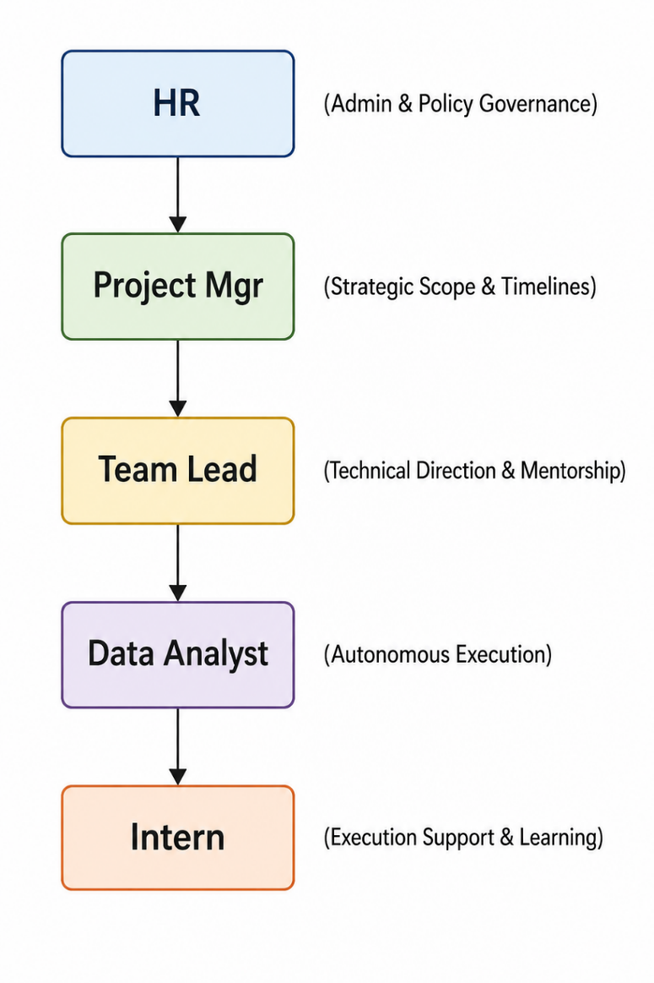
The Reporting Structure Explained
Human Resources (HR)
While not involved in daily technical standups, HR sits at the structural periphery, governing administrative policy, onboarding, performance standards, and systemic conflict resolution. They establish the macro-framework within which the entire department hires, trains, and retains talent.
Project Manager (PM)
The Project Manager focuses on the macro-timeline and business scope. They manage project roadmaps, resource allocation, and cross-departmental delivery dates. The PM ensures that the data team’s output is delivered on time to serve external teams like Marketing, Finance, or Executive Leadership.
Team Lead
The Team Lead bridge the gap between strategic management and code execution. Usually an experienced senior analyst, they translate the PM’s timelines into specific, manageable technical tasks. They assign work, review code, guide data architecture decisions, and provide direct mentorship to the analytical staff.
Data Analyst
The core individual contributors of the department. Data Analysts operate autonomously to manage data extraction, build pipelines, run statistical analyses, and maintain dashboards. They take ownership of specific business domains and are responsible for the mathematical accuracy of their insights.
Intern
The Intern occupies the execution support tier. They assist Data Analysts and Team Leads by handling data preparation, basic documentation, initial exploratory analysis, and dashboard maintenance. Their work is heavily reviewed, allowing them to learn corporate best practices while relieving the core team of foundational tasks.
Why Hierarchy is Important
A well-defined hierarchy is essential for operational stability, particularly within data teams, for several distinct reasons:
- Clear Lines of Escalation: When a data pipeline breaks, a server crashes, or data discrepancies occur, a strict reporting line prevents confusion. An intern knows to immediately notify their Team Lead, who can evaluate whether to handle it technically or escalate it to the Project Manager to adjust business timelines.
- Effective Quality Assurance: Data analysis directly drives multi-million-dollar executive decisions. A layered hierarchy enforces a code review and validation system. An intern's work is vetted by an analyst, which is then double-checked by a team lead before it ever reaches a business stakeholder, significantly reducing the risk of costly analytical errors.
- Structured Mentorship & Career Pathing: A visible hierarchy gives junior members a clear view of their potential career progression. It pairs interns with direct mentors (Analysts/Team Leads) who can provide actionable technical feedback, ensuring that learning objectives are met systematically rather than randomly.
- Resource Optimization: It prevents skilled senior assets from being bogged down by repetitive tasks. By delegating data cleaning and template formatting to an intern, senior staff can focus on high-impact predictive analytics, optimizing the team's overall financial ROI.

5.Documentation
Documentation is the memory of a data team. Without it, insights are lost, code becomes unmaintainable, and organizations waste time reproducing previous work.
Key Documentation Types
Requirement Documents
Often called a Product Requirement Document (PRD) or Business Requirements Document (BRD), this asset is drafted before any code is written or databases are queried. It acts as a contract between the data team and the business stakeholders. A standard requirements document explicitly outlines:
- The core business problem being addressed.
- The specific Key Performance Indicators (KPIs) needed.
- The target audience for the insights.
- Project constraints, data sources required, and final deadlines.
Analysis Reports
An Analysis Report translates raw code and mathematical models into an easily digestible business narrative. This document captures the final outcomes of exploratory data analysis or statistical testing. It includes high-level executive summaries, critical visualizations, data-backed conclusions, and actionable business recommendations. By preserving the context of why certain conclusions were reached, it prevents future teams from misinterpreting old data.
Dashboard Documentation
Dashboards are dynamic, which means they can easily confuse users if they lack proper documentation. Dashboard documentation serves as a user manual for business stakeholders and a technical guide for future analysts. It includes:
- A Data Dictionary: Clear definitions of every metric and field used (e.g., clarifying exactly how "Active User" or "Churn Rate" is calculated).
- Data Lineage: Documentation detailing where the data originates, how often it refreshes, and what transformations occur behind the scenes.
- User Guide: Instructions on how to use interactive filters, drill-downs, and slicers.
Project Documentation
Project documentation tracks the engineering lifecycle of a data project. It is typically stored alongside code repositories (such as a README.md file in Git) or on internal wikis like Confluence. It records the environment setups, required software packages/dependencies, code architecture logic, testing protocols, and structural change logs. This ensures that any engineer or analyst can step into the project and understand how it functions immediately.

Importance of Documentation
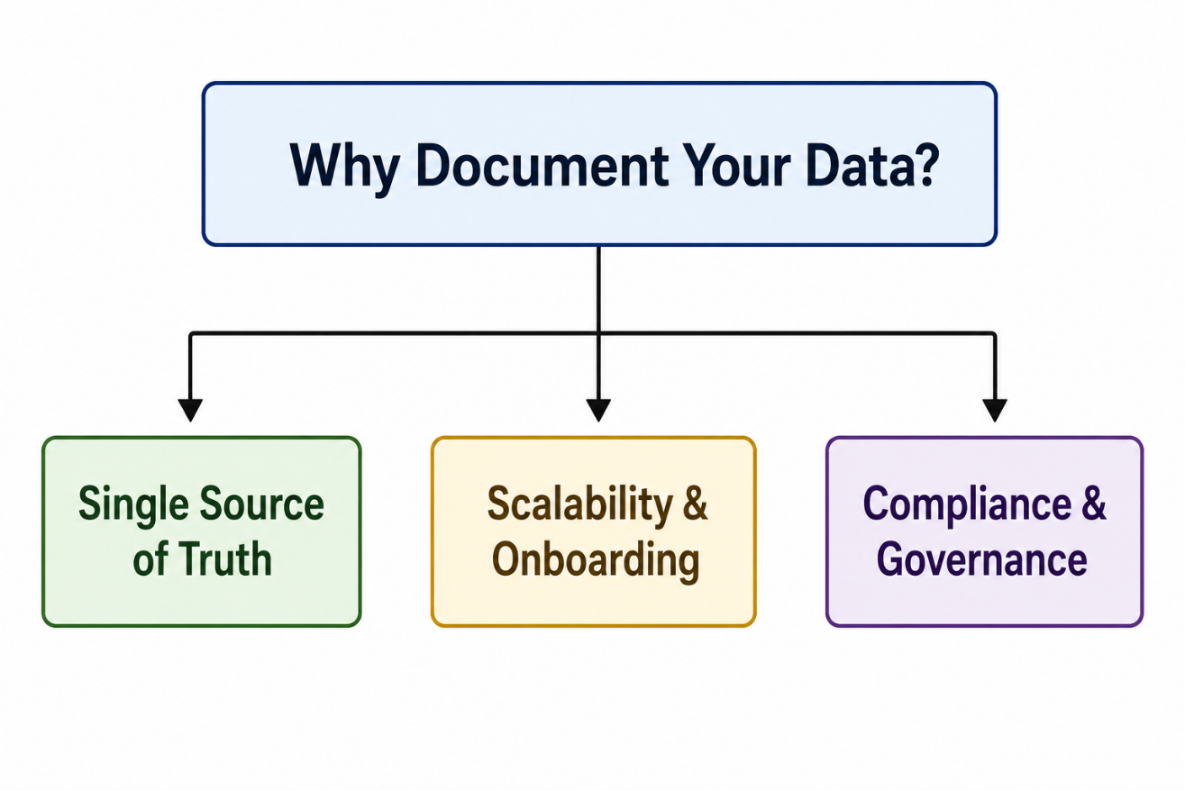
Maintaining rigorous documentation standards provides several distinct operational advantages to an organization:
- Establishes a Single Source of Truth: Different departments often define metrics differently—for example, Sales and Marketing might calculate "conversion rate" using entirely different formulas. Documentation standardizes these definitions across the company, preventing conflicting reports.
- Accelerates Scaling and Onboarding: When a new analyst or intern joins a team, comprehensive project and dashboard documentation reduces their onboarding time from months to weeks. They can self-educate on the team's data structures without constantly interrupting senior resources.
- Mitigates Key-Person Risk: If a critical team member leaves the company, undocumented data pipelines become "black boxes" that no one else knows how to fix or update. Documentation ensures that intellectual property stays with the organization, not the individual.
- Ensures Regulatory Compliance and Data Governance: With strict data privacy laws globally (such as GDPR and CCPA), organizations must be able to prove exactly how they collect, transform, and store user data. Thorough documentation serves as an official audit trail for compliance teams.

6.Templates
In a fast-paced data environment, efficiency is driven by repeatability. Templates serve as pre-structured, reusable frameworks that eliminate the need to build analytical assets from scratch for every new project.
Core Template Types
Excel Template
Excel templates provide standardized layouts for data entry, ad-hoc financial modeling, and quick statistical evaluations. These templates typically feature:
- Pre-formatted Styles: Uniform typography, corporate color palettes, and frozen header rows for high scannability.
- Locked Calculation Sheets: Dedicated sheets containing pre-written formulas (such as XLOOKUP blocks or nested conditional statements) where cell editing is locked to prevent users from accidentally corrupting the math.
- Standard Data Input Zones: Clearly marked rows and columns where raw data can be pasted, automatically triggering downstream charts and pivot updates.
Dashboard Template
A dashboard template establishes a uniform user experience (UX) and visual skeleton within Business Intelligence platforms like Power BI or Tableau. It defines:
- Grid Layouts: Fixed placements for high-level numbers (KPI cards always at the top left), time-series trends (middle canvas), and granular data tables (bottom).
- Theme Files: Embedded corporate color swatches, font sizes, and button design styles that align with company branding.
- Template Data Connections: Pre-configured data schemas and date tables, enabling the analyst to swap out the underlying data source while preserving all interactive filters, slicers, and visual cards.
Report Template
Report templates guide the structure of periodic analytical deliverables, whether formatted as slide decks (PowerPoint/Google Slides), text documents (Word/Confluence), or automated email notifications. These templates ensure that the analytical narrative follows a logical flow:
1. Executive Summary (High-level business takeaways)
2. Core Metrics & Key Performance Indicators (KPIs)
3. Data Visualizations & Deep-Dive Analysis
4. Strategic Business Recommendations
5. Appendix (Data sources, assumptions, and methodology)

Advantages of Standard Templates
Implementing a team-wide repository of standardized templates offers several key benefits to an enterprise data operation:
- Drastic Time Savings: Analysts can skip the tedious design phase—such as adjusting chart fonts, setting margins, and picking colors. This allows them to focus 100% of their energy on data interpretation and insight generation, accelerating the delivery timeline.
- Brand Consistency: When executives receive reports from different analysts across various departments, a unified template design ensures a professional corporate image. Every asset looks, feels, and reads as though it came from a single cohesive data team.
- Reduced Human Error: Building formulas or configuring dashboard filtering paths repeatedly from scratch introduces the risk of technical oversight. Templates utilize thoroughly tested, error-checked structural baselines, ensuring data reporting remains reliable.
- Lower Cognitive Load for Stakeholders: When business users look at standardized dashboard and report formats, they do not have to waste time figuring out how to read a new chart layout. Because they know exactly where to look for specific KPIs, they can digest the insights and make strategic decisions much faster.

7. Data Analytics Strategies
Analytical execution is only as valuable as the strategic framework driving it. Organizations deploy specific analytics strategies to convert historical and real-time data into a continuous competitive advantage.
Data-Driven Decision Making (DDDM)
Data-Driven Decision Making is the practice of aligning corporate strategy with verified data metrics rather than relying on intuition, observation, or executive gut feelings.
- The Shift from Reactive to Proactive: Instead of launching a product and waiting to see if it succeeds, a DDDM strategy leverages historical customer behavior data, predictive modeling, and market analysis to quantify the probability of success before significant capital is committed.
- Objective Evaluation: DDDM democratizes operations within a business. By establishing data as the ultimate truth, project evaluations become free from internal corporate bias or political influence. Ideas are judged on clear, measurable evidence, significantly reducing strategic risk.
Automation
Modern enterprise data scales exponentially, making manual processing completely unsustainable. Automation strategies focus on eliminating repetitive human intervention across the data pipeline:
- ETL/ELT Pipelines: Automated scheduling scripts (using Python, SQL, or orchestrators like Apache Airflow) are written to automatically Extract data from external sources, Transform its structure into a clean format, and Load it into enterprise data warehouses every evening.
- Alerting Frameworks: Automation turns dashboards from passive observation boards into active notification systems. For example, anomaly detection models can be automated to trigger instantaneous Slack or email alerts to engineers the moment website checkout drop-offs spike above a 5% statistical threshold.
KPI Monitoring
Key Performance Indicator (KPI) monitoring is the strategy of identifying, tracking, and displaying an organization's most critical health metrics over time.
- Preventing Information Overload: A successful strategy separates vanity metrics (such as raw page views) from actionable business KPIs (such as Customer Lifetime Value, Conversion Rate, or Net Promoter Score).
- Dynamic Baselining: Modern KPI monitoring goes beyond comparing performance against static monthly goals. Analysts establish dynamic baselines using moving averages and seasonality adjustments. This helps determine whether a minor drop in performance is a true operational crisis or merely a predictable seasonal trend.

Continuous Improvement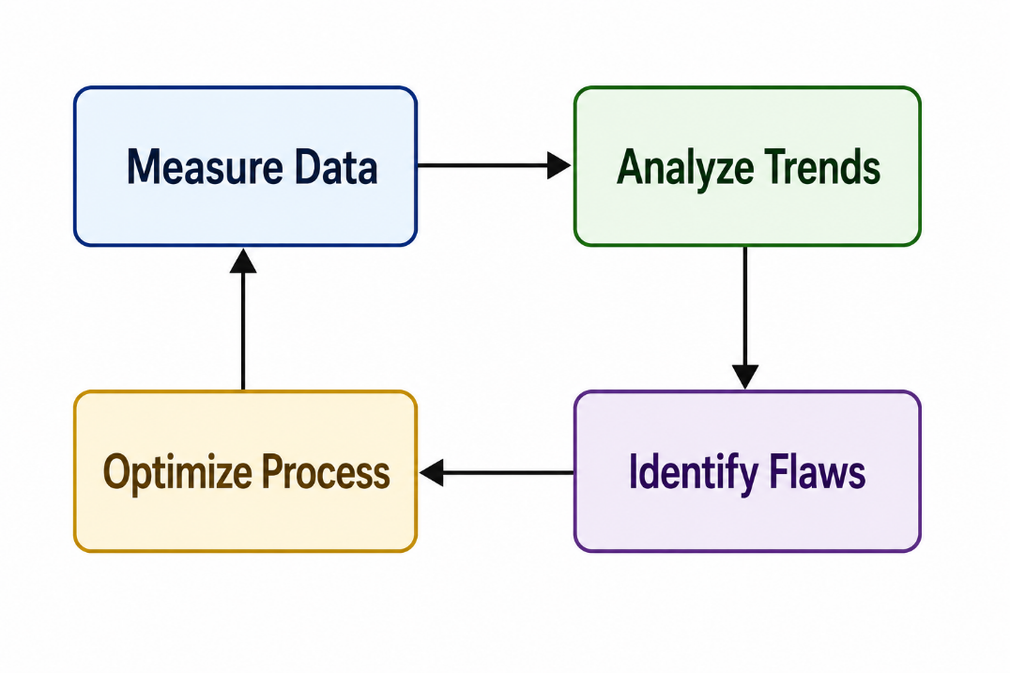

Rooted in operational frameworks like Six Sigma and Lean, continuous improvement in analytics utilizes feedback loops to constantly optimize business processes.
- The Optimization Loop: Analysts monitor an asset or operational workflow, spot an inefficiency through data trends, recommend a strategic change, and then immediately measure the post-implementation data to quantify the impact of that change.
- A/B and Multivariate Testing: Continuous improvement relies heavily on experimental data. By testing a baseline process against a modified variant (such as comparing two different user check-out flows), analysts collect objective data to prove whether an adjustment yields a statistically significant improvement in operational efficiency or revenue.

Here is a breakdown of the core pillars that define a modern data analytics strategy.
1. Data-Driven Decision Making (DDDM)
Data-driven decision making is the practice of aligning business goals with verifiable data rather than relying solely on gut feeling, anecdote, or "the way we've always done it."
- The Shift: It transitions an organization from a reactive state (responding to a crisis after it happens) to a proactive or predictive state (identifying trends and mitigating risks early).
- Key Benefit: It removes cognitive bias from leadership choices. By analyzing historical performance and market indicators, businesses can validate hypotheses before investing heavy resources.
2. Automation
Data is only valuable if it is accessible and fresh. Automation removes the manual bottleneck of data management, allowing teams to focus on strategy rather than data prep.
- ETL Pipelines: Automating the Extract, Transform, Load (ETL) process ensures that data from various sources (CRM, web traffic, financial software) flows seamlessly into a central data warehouse without human intervention.
- Automated Reporting: Instead of analysts spending hours compiling weekly spreadsheets, automated dashboards refresh in real-time. This reduces human error and drastically cuts down time-to-insight.
3. KPI Monitoring
Key Performance Indicators (KPIs) act as the compass for your business strategy. Monitoring them effectively transforms raw data into a narrative of business health.
- Focus Over Fragment: Effective KPI monitoring isn't about tracking every metric possible; it is about tracking the vital metrics that directly impact growth (e.g., Customer Acquisition Cost, Churn Rate, or Net Profit Margin).
- Visual Dashboards: Utilizing tools like Tableau, Power BI, or Looker allows stakeholders to see performance at a glance. Good monitoring systems use threshold alerts—notifying key personnel automatically if a specific KPI drops below a safe baseline.
4. Continuous Improvement
A data strategy is not a "one-and-done" project; it is an iterative loop. Continuous improvement (often operationalized via frameworks like the PDCA cycle: Plan-Do-Check-Act) ensures the business constantly optimizes.
- Feedback Loops: Data reveals the gaps between projected goals and actual performance. By analyzing these gaps, teams can run targeted A/B tests, tweak product features, or optimize marketing funnels.
- Data Strategy Evolution: As the business grows, the data strategy itself must improve. This means regularly auditing data quality, updating data models, and upskilling teams to handle more advanced analytics (like machine learning or predictive forecasting).

8.Analytics Workflow (Funnel)
The data analytics workflow is best understood as a funnel. At the top of the funnel, raw, unrefined data enters in massive volumes. As it moves down through sequential stages, it is systematically filtered, structured, and distilled into high-value strategic execution at the bottom.
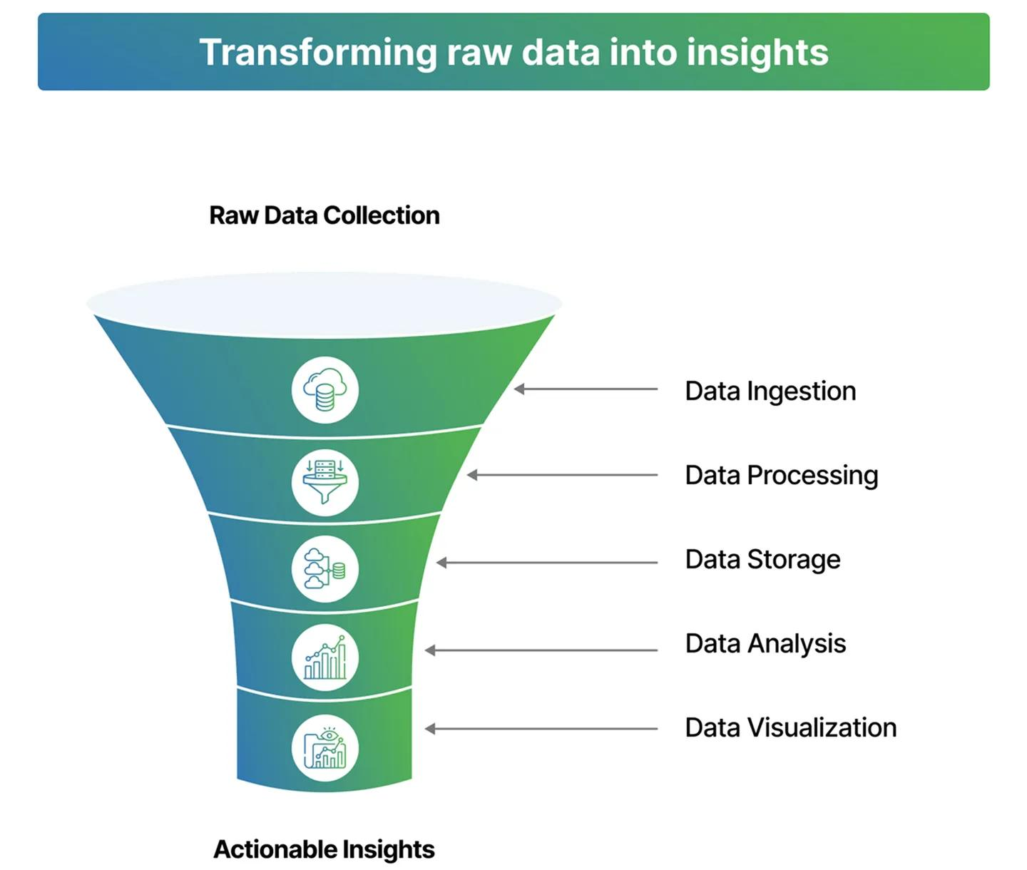

Stages of the Analytics Funnel
1. Data Collection
The workflow begins by gathering raw information from all available infrastructure points—such as customer transactions, user application logs, third-party marketing tools, and IoT devices. This step converts physical or digital real-world activities into numerical and structural records within enterprise data storage.
2. Data Cleaning
Raw data is notoriously flawed. The cleaning phase acts as a processing facility where analysts run validation routines, handle missing data points, remove duplicate records, fix data type mismatches, and filter out noise. This transforms unreliable inputs into a pristine dataset optimized for math and logic.
3. Data Analysis
With a clean dataset established, the analyst mines the data for answers. Using statistical modeling, exploratory programming libraries (like Pandas), and structural querying, the analyst looks for correlations, anomalies, distribution patterns, and historical changes that explain why specific business metrics are moving.
4. Visualization
Human brains cannot process hundreds of thousands of raw text rows efficiently. The visualization stage translates abstract mathematical findings and complex tabular datasets into clear geometric shapes—such as charts, trend graphs, and geographic maps. This step contextualizes numbers visually to highlight key trends instantaneously.
5. Reporting
Reporting bundles visualizations and structured data insights into an organized, easily digestible package tailored for a specific audience. Whether compiled into a weekly executive slide deck, a automated dashboard, or an analytics summary, this stage ensures the critical operational insights are surfaced cleanly to business operators.
6. Business Decision
The final, high-impact outcome at the tip of the funnel. Armed with clear reports, business leaders take decisive action—such as shifting marketing budgets, updating product feature designs, altering inventory levels, or updating pricing structures—confident that their choices are backed by empirical evidence.
Why Every Stage is Critical
The analytics workflow operates as a chronological dependency chain. The integrity of the final business decision relies entirely on the successful execution of every preceding step:
- The "Garbage In, Garbage Out" Law: If Data Collection pulls broken fields or Data Cleaning fails to scrub out duplicates, the subsequent analysis will be flawed. Making decisions based on corrupted data can cost a company millions of dollars in misallocated capital.
- Analysis Unlocks Meaning: Skipping straight from collection to visualization creates "pretty pictures" that lack depth. Without deep Data Analysis, charts only show what happened, leaving leadership entirely blind to the why behind the numbers.
- Communication Bridges the Gap: An analyst could discover an incredibly valuable operational insight during the analysis phase, but if they fail at Visualization and Reporting, that insight remains locked behind complex code. Clear presentation translates technical discoveries into organizational action.
Stages of the Analytics Funnel
1. Data Collection
The workflow begins by gathering raw information from all available infrastructure points—such as customer transactions, user application logs, third-party marketing tools, and IoT devices. This step converts physical or digital real-world activities into numerical and structural records within enterprise data storage.
2. Data Cleaning
Raw data is notoriously flawed. The cleaning phase acts as a processing facility where analysts run validation routines, handle missing data points, remove duplicate records, fix data type mismatches, and filter out noise. This transforms unreliable inputs into a pristine dataset optimized for math and logic.
3. Data Analysis
With a clean dataset established, the analyst mines the data for answers. Using statistical modeling, exploratory programming libraries (like Pandas), and structural querying, the analyst looks for correlations, anomalies, distribution patterns, and historical changes that explain why specific business metrics are moving.
4. Visualization
Human brains cannot process hundreds of thousands of raw text rows efficiently. The visualization stage translates abstract mathematical findings and complex tabular datasets into clear geometric shapes—such as charts, trend graphs, and geographic maps. This step contextualizes numbers visually to highlight key trends instantaneously.
5. Reporting
Reporting bundles visualizations and structured data insights into an organized, easily digestible package tailored for a specific audience. Whether compiled into a weekly executive slide deck, a automated dashboard, or an analytics summary, this stage ensures the critical operational insights are surfaced cleanly to business operators.
6. Business Decision
The final, high-impact outcome at the tip of the funnel. Armed with clear reports, business leaders take decisive action—such as shifting marketing budgets, updating product feature designs, altering inventory levels, or updating pricing structures—confident that their choices are backed by empirical evidence.
Why Every Stage is Critical
The analytics workflow operates as a chronological dependency chain. The integrity of the final business decision relies entirely on the successful execution of every preceding step:
- The "Garbage In, Garbage Out" Law: If Data Collection pulls broken fields or Data Cleaning fails to scrub out duplicates, the subsequent analysis will be flawed. Making decisions based on corrupted data can cost a company millions of dollars in misallocated capital.
- Analysis Unlocks Meaning: Skipping straight from collection to visualization creates "pretty pictures" that lack depth. Without deep Data Analysis, charts only show what happened, leaving leadership entirely blind to the why behind the numbers.
- Communication Bridges the Gap: An analyst could discover an incredibly valuable operational insight during the analysis phase, but if they fail at Visualization and Reporting, that insight remains locked behind complex code. Clear presentation translates technical discoveries into organizational action.

9.Glossary
To ensure clear communication across both technical and business teams, it is essential to establish a standardized vocabulary. Below are definitions for the core terms used throughout this thesis.
KPI (Key Performance Indicator)
A KPI is a quantifiable metric that evaluates how effectively an organization, department, or specific initiative is achieving its core strategic business objectives. Unlike general metrics, KPIs are directly linked to high-level goals—such as target profit margins, customer retention thresholds, or operational efficiency rates—and are used by leadership to guide critical decision-making.
Dashboard
A dashboard is an interactive, visual interface that aggregates and displays real-time or periodic data from various business channels. Built using Business Intelligence (BI) software, it allows stakeholders to track KPIs, monitor operational health, and filter complex datasets down to specific regions, dates, or product categories at a glance.
Dataset
A dataset is a structured collection of related data points, typically organized in a tabular format with rows representing individual records and columns representing distinct variables or attributes. Datasets serve as the primary raw material that analysts extract from databases to clean, manipulate, and study.
ETL (Extract, Transform, Load)
ETL is a foundational three-step data integration pipeline process used to move data from source systems into a centralized data warehouse:
- Extract: Pulling raw data from disparate, unstructured, or isolated corporate sources.
- Transform: Cleaning, deduplicating, reformatting, and structuring the data to fit analytical requirements.
- Load: Depositing the newly refined data into a target data warehouse or database for immediate use by analysts.
Query
A query is a precise, written instruction used to request, manipulate, or retrieve specific information from a database management system. Most analytical queries are written in Structured Query Language (SQL) and dictate exactly which tables to look in, how to filter the rows, and how to aggregate the final output.
Visualization
Data visualization is the practice of translating abstract, complex datasets into graphical representations—such as bar charts, line graphs, scatter plots, and heatmaps. By leveraging human visual processing, it makes patterns, anomalies, and multi-dimensional trends instantly scannable and easy to understand.
Insights
An insight is a deep, non-obvious understanding gained from analyzing data that directly explains why a trend is occurring or what future behavior can be expected. Insights move beyond basic observations; they connect data findings directly to business context, providing the strategic rationale needed to take profitable corporate action.
Metrics
A metric is any standard, quantifiable measurement used to track and assess a specific business process, system performance, or user activity (e.g., page views, bounce rates, or daily active users). While all KPIs are metrics, not all metrics are KPIs—metrics track general operational health, whereas KPIs track the ultimate markers of organizational success.

10.Performance Metrics
1. Accuracy
Accuracy measures the degree to which your analytical data matches real-world truth or your system of record (like your core financial ledger or production database).
- The Reality: Data pipelines frequently drop rows, duplicate entries during sync errors, or mishandle time zones.
- How it's measured: Organizations often run automated data quality checks (using tools like Great Expectations or Soda) to verify data types, check null values, and compare row counts between sources and destinations.
2. Report Completion
Report Completion tracks whether your data pipelines, scheduled reports, and data refreshes successfully finish on time.
- The Data SLA: Most businesses rely on "Service Level Agreements" (SLAs) for their data—for example, "The executive dashboard must refresh by 6:00 AM every morning."
- Why it matters: If an executive logs in at 8:00 AM and sees yesterday's data because a pipeline crashed at midnight, the completion metric fails, and operational momentum stalls.
3. Dashboard Quality
Dashboard quality assesses user adoption, relevance, and visual clarity. It answers the question: Are our visualization tools actually useful, or are they just digital clutter?
- The Danger of Bloat: Over time, companies suffer from "dashboard sprawl"—hundreds of reports are built, but only a fraction are actively used.
- How it's measured: Quality is typically tracked via usage metrics (active users, session length) and user feedback surveys to ensure dashboards remain intuitive, clean, and directly aligned with business goals.
4. Query Efficiency
Query efficiency measures how fast and cost-effectively your data infrastructure processes information.
- Performance vs. Cost: In modern cloud data warehouses (like Snowflake or BigQuery), you pay for the compute power you consume. A poorly written SQL query with inefficient joins can take 20 minutes to run and cost hundreds of dollars.
- Why it matters: Highly efficient queries ensure that business users get their answers in seconds while keeping cloud computing bills from spiraling out of control.
Importance of Measuring Performance
If you don't measure the performance of your data platform, you are flying blind. Tracking these metrics is essential for three major reasons:
- Building and Maintaining Trust: Trust in data takes months to build and only seconds to destroy. If a dashboard is consistently inaccurate or sluggish, business leaders will abandon it and return to making gut-based decisions or relying on siloed Excel sheets.
- Cloud Cost Optimization: In modern data architecture, poor performance directly equals wasted budget. Monitoring query efficiency allows data teams to optimize indexing, partition tables correctly, and prevent expensive, runaway queries.
- Proactive Incident Management: Measuring performance shifts your data team from a reactive state to a proactive one. Instead of waiting for the CEO to ping you saying a chart looks broken, automated performance monitoring alerts your data engineers the exact minute a pipeline fails.

11.Domain Knowledge
To operate effectively, a data professional must possess a balanced understanding of technical ecosystems and business economics. This domain knowledge ensures that code and queries are constructed to solve real-world corporate challenges.
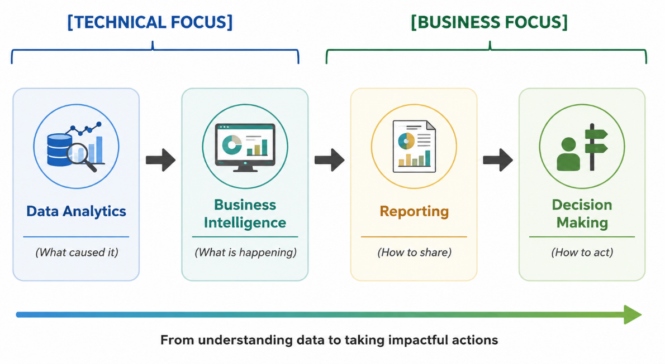
Data Analytics
Data Analytics is the investigative engine of the data domain. It focuses primarily on discovering deeper patterns, relationships, and root causes within historical and current datasets.
- Diagnostic & Predictive Approach: While basic observation notes what happened, data analytics seeks to answer why it happened (diagnostic analytics) and what might happen next (predictive analytics). It utilizes statistical techniques, programming scripts (Python/R), and data modeling to isolate variables and validate business hypotheses.
- Exploratory Data Mining: It requires looking into granular data structures to find hidden trends, customer segment anomalies, or operational bottlenecks that are not readily visible on standard corporate balance sheets.
Business Intelligence (BI)
Business Intelligence is the strategic infrastructure that converts analyzed data into a continuous, structured overview of corporate performance.
- Descriptive Framework: BI focuses heavily on the present and immediate past (descriptive analytics). It establishes the permanent infrastructure—such as automated data models, star schemas, and software stacks—needed to track corporate operations consistently.
- Democratizing Data: The goal of a strong BI strategy is to create a reliable "single source of truth." By establishing centralized data warehouses and user-friendly platforms, BI removes technical gatekeepers, allowing department heads to explore structured data safely on their own.
Reporting
Reporting is the communication layer of domain knowledge. It is the structured delivery mechanism through which data insights are packaged and distributed across an organization.
- Contextualizing Information: Raw numbers carry zero inherent meaning. Reporting takes the data surfaced by BI pipelines and frames it against specific targets, historical baselines, and industry benchmarks.
- Tailored Delivery: Effective reporting recognizes that different audiences require different layers of detail. A marketing manager might need a daily report tracking ad-click conversions, whereas the Chief Marketing Officer (CMO) requires a high-level quarterly report summarizing overall Return on Ad Spend (ROAS).
Decision Making
Decision Making is the ultimate commercial destination for all analytics, BI, and reporting initiatives. The entire data pipeline exists to optimize this final human action.
- Mitigating Execution Risk: Business leaders must constantly make high-stakes choices regarding product pricing, resource expansion, or capital allocation. Domain knowledge allows data professionals to support these leaders by replacing intuition with empirical evidence, transforming high-risk guesses into calculated strategic maneuvers.
- Establishing Feedback Loops: In a sophisticated data environment, decision-making is not a one-time event. Once a data-backed choice is implemented, the reporting and BI pipelines immediately begin tracking its real-world impact, creating a continuous feedback loop that guides the company toward growth.

12.Cross-Functional Teams
In an enterprise environment, a data team never operates in isolation. Developing an analytical asset requires continuous collaboration across an ecosystem of specialized, cross-functional business units.
Roles within the Cross-Functional Ecosystem
Human Resources (HR)
The foundational talent and culture partner. HR secures highly skilled technical professionals, designs specialized onboarding paths, manages performance frameworks, and establishes professional development programs to ensure long-term retention within the data department.
Technical Team
The builders and engineers of the data infrastructure. This unit includes Data Engineers, Database Administrators, and Senior Analysts who design data warehouses, maintain ETL/ELT pipelines, ensure data security, optimize server query performance, and write the core scripts required to keep data clean and accessible.
Project Manager (PM)
The operational conductor of the development cycle. The PM defines project boundaries, sets delivery schedules, removes development blockers, and manages the team's capacity using Agile frameworks. They act as the primary translator, protecting developers from scope creep while keeping external business leaders updated on timelines.
Business Team
The internal domain clients, encompassing units like Marketing, Finance, Sales, and Product Management. They supply the real-world business context, define the problem statements, establish the core Key Performance Indicators (KPIs) they need to track, and ultimately apply the final data insights to live operations.
Quality Assurance (QA) Team
The gatekeepers of product reliability. The QA team independently audits code, checks data models for accuracy, ensures dashboard filters function perfectly across different user permissions, and aggressively tests edge cases to confirm that no corrupted metrics reach corporate executives.
How They Work Together
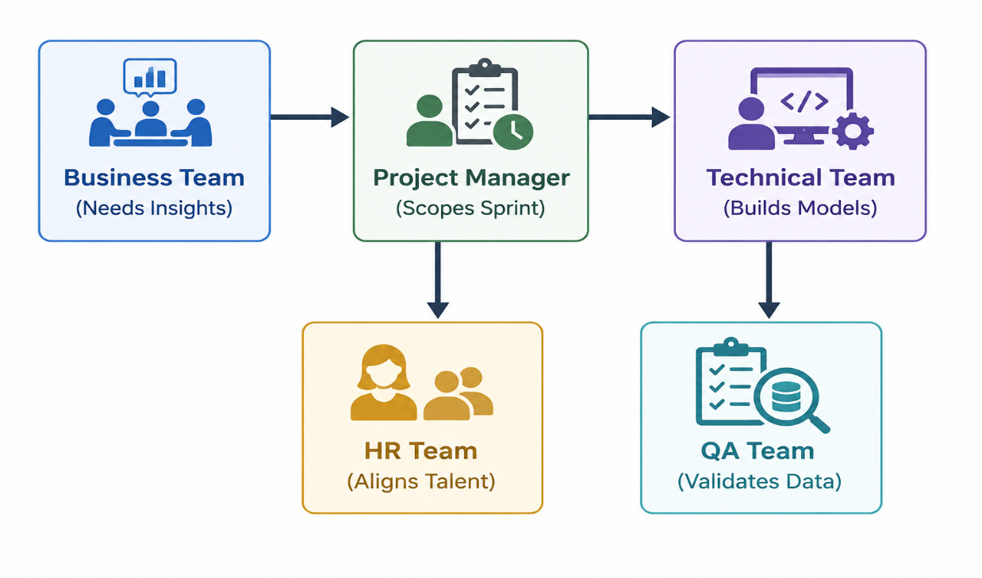
The success of a data-driven project relies entirely on a highly synchronized, sequential workflow among these five distinct business units:
- Scoping the Strategy: The Business Team identifies a critical revenue or operational problem and approaches the Project Manager. The PM works with both the business unit and the Technical Team to break the request down into defined user stories and technical tasks for the next development sprint.
- Assembling the Talent: To support long-term initiatives or handle technical gaps discovered during scoping, HR steps in to target, interview, and onboard specialized data professionals or interns, aligning human capital with upcoming technical needs.
- Development and Engineering: The Technical Team queries the databases, cleans the raw information, applies statistical models, and builds the interactive dashboards according to the specifications outlined by the business unit.
- Rigorous Validation: Before deployment, the QA Team conducts comprehensive testing on the data pipeline, ensuring the numbers are completely accurate and the visual components display correctly.
- Operational Execution: Once verified, the dashboard is released. The Business Team uses this data to make informed strategic decisions, while the Project Manager monitors performance metrics to evaluate the project's overall success.

13.Technology Stack
A robust data analytics infrastructure requires an integrated stack of technologies. Each tool handles a specific phase of the data lifecycle—from ingestion and transformation to deployment and version tracking.
Microsoft Excel
Excel serves as the primary gateway for quick desktop data manipulation, rapid prototyping, and financial forecasting.
- Operational Engine: Utilizing its grid-based environment, it processes structured data through tabular formulas, logical lookups (XLOOKUP), and nested conditional blocks (SUMIFS).
- Ad-Hoc Analysis: Excel allows analysts to connect directly to local flat files or web queries, construct rapid data aggregates via Pivot Tables, and apply conditional formatting to instantly isolate missing entries or outlier values before initiating heavy warehouse pipelines.
SQL (Structured Query Language)
SQL is the foundational domain-specific programming language used to interface with relational database management systems (RDBMS) like Snowflake, PostgreSQL, or SQL Server.
- Data Retrieval and Aggregation: It handles the core extraction layer of the data pipeline. Analysts write optimized queries utilizing relational algebra—such as grouping fields (GROUP BY), sorting sets (ORDER BY), and filtering rows (WHERE / HAVING).
- Relational Mapping: It enables complex data modeling by stitching normalized, scattered data schemas back together using various join conditions (INNER, LEFT, RIGHT, FULL OUTER). This provides a comprehensive view across disconnected business entities.
Power BI
Power BI is a sophisticated enterprise business intelligence (BI) platform used to scale data modeling and self-service analytics reporting.
- Data Transformation & Modeling: Powered by the Power Query engine, it ingests multi-source data feeds, handles schema normalization, and builds structured star schemas. It utilizes Data Analysis Expressions (DAX) to build complex, calculated measures and time-intelligence indicators.
- Interactive Visualization: It translates database models into fully interactive, secured cloud dashboards. Features include responsive visualization charts, dynamic cross-filtering slicers, and row-level security (RLS) paths designed to match corporate identity parameters.
Python
Python is an open-source, high-level, multi-paradigm programming language that represents the industry standard for advanced data science, engineering, and predictive workflows.
- Data Manipulation (Pandas & NumPy): Through vectorization and high-performance in-memory DataFrames, Python manipulates granular text strings, complex arrays, and nested structures (like JSON) that are difficult to parse inside traditional databases.
- Script Automation: Python operates as an orchestration tool. Analysts write automated scripts that interface with external web REST APIs, execute scheduled cleaning routines, parse web elements, or deposit refined data directly into business directories.
Git
Git is a distributed version control system designed to track file edits, manage source code history, and coordinate collaborative software development workflows among technical teams.
- Version Management: Git records sequential code adjustments as immutable commits. This allows data teams to safely test experimental analysis scripts or database migration code with the security of a complete, step-by-step history to roll back to if bugs appear.
- Collaborative Branching: Utilizing central hosting systems like GitHub or GitLab, Git implements branching models (e.g., Gitflow). Multiple analysts can write code on parallel features simultaneously without overwriting each other's changes, utilizing peer-reviewed Pull Requests (PRs) to maintain production code quality.

14.Environment Setup
Setting up an analyst’s local workstation requires a careful blend of office tools, database servers, BI platforms, and programming environments.
1. Microsoft Office (Excel)
- Why It Is Required: Excel is the universal translator of corporate data. It is needed for opening quick CSV exports, creating light data prototypes, drafting ad-hoc financial models, and reviewing report layouts before final delivery.
- Installation Steps:
  - Go to the official Microsoft 365 portal and log in using your enterprise or institutional credentials.
  - Click the Install apps button in the top right corner of the dashboard.
  - Run the downloaded setup executable (.exe for Windows or .pkg for Mac) and follow the onscreen wizard.
  - Once installed, open Excel and sign in to activate your corporate license.
2. MySQL Server & MySQL Workbench
- Why It Is Required: Analysts need a localized relational database management system (RDBMS) to safely practice querying, design sandbox tables, and test complex SQL scripts without running the risk of slowing down production enterprise servers.
- Installation Steps:
  - Visit the official MySQL Community Downloads page.
  - Download the MySQL Installer for Windows (which includes both the SQL Server and the Workbench GUI).
  - Run the installer and select the Developer Default setup type to bundle the server, shell, and workbench together.
  - Set up your root password when prompted, leave the port configuration at default (3306), and complete the installation.
  - Launch MySQL Workbench to connect to your local server instance and begin writing queries.
3. Power BI Desktop
- Why It Is Required: This is the primary authoring workspace used to build enterprise data models, connect to disparate data streams, write DAX (Data Analysis Expressions) formulas, and design the final interactive visuals before publishing them to the cloud.
- Installation Steps:
  - Open the Microsoft Store on your Windows device (recommended for automatic, seamless monthly updates).
  - Search for Power BI Desktop and click Get/Install.
  - (Alternative) If using a managed machine, download the standalone .msi setup file directly from the official Microsoft Power BI download page.
  - Launch the application; no initial license login is required to start building local files.
4. Anaconda Distribution & Jupyter Notebook
- Why It Is Required: Anaconda provides a self-contained data science environment. It pre-installs Python along with critical, complex mathematical libraries (like Pandas, NumPy, and Scikit-Learn) and pairs them with Jupyter Notebook—an interactive environment ideal for writing and documenting data-cleaning scripts.
- Installation Steps:
  - Go to the Anaconda Downloads page and download the graphical installer for your operating system.
  - Run the installer. Ensure you check the box to Register Anaconda3 as my default Python when prompted.
  - Once complete, open the Anaconda Navigator desktop application.
  - Find the Jupyter Notebook card and click Launch. This opens a web-based coding interface in your browser.
5. Git
- Why It Is Required: Git is essential for technical version control. It tracks line-by-line changes in your SQL files and Python scripts, allows you to pull down collaborative code from remote repositories (like GitHub), and ensures you can safely backup and roll back your work.
- Installation Steps:
  - Navigate to the official Git SCM website.
  - Download the appropriate binary setup for your system architecture.
  - Execute the installer. You can safely accept the default choices for terminal integration and line endings.
  - Open your command line interface (Terminal or Git Bash) and run the following commands to configure your global identity:
# Bash
git config --global user.name "vedant_jamdade"
git config --global user.email "vedant.clustor@company.com"

15.Agile Methodology
Modern software and data engineering teams operate under flexible iterative structures rather than rigid, linear planning. Agile methodologies ensure that data teams can adapt seamlessly to changing business requirements without discarding previous progress.
Core Frameworks
Agile
Agile is a conceptual project management philosophy centered on iterative development, continuous collaboration, and open flexibility. Rather than planning a massive analytics project over a multi-month timeline and delivering a single final product (the traditional Waterfall method), Agile breaks projects into small, functional components that are continuously developed, tested, and shipped to users for immediate feedback.
Scrum
Scrum is the specific, highly structured operational framework used to implement Agile principles. It organizes teams into small, cross-functional units driven by distinct roles: the Product Owner (who represents business priorities), the Scrum Master (who removes workflow obstacles), and the Development Team (analysts and engineers). Scrum provides a precise cadence of repeating meetings, roles, and artifacts to guide execution.
Sprints & Structural Elements
Sprint
The basic building block of Scrum development. A sprint is a fixed, time-boxed iteration—typically lasting 1 to 2 weeks—during which a team commits to finishing a specific, pre-selected set of data models, dashboard features, or pipeline updates. Once a sprint begins, its scope is locked to protect the engineering team from mid-week changes.
User Story
A user story is a non-technical, high-level description of a feature written entirely from the perspective of the end user. It outlines the who, what, and why of a task to keep developers focused on user value. User stories follow a standard syntactic formula:
"As a [type of user], I want to [perform an action] so that I can [achieve a specific benefit]."
Epic
An Epic is a large, complex body of work that cannot be completed within a single sprint. It serves as an overarching strategic theme that can be broken down into dozens of smaller, bite-sized user stories. For example, "Build a localized financial forecasting pipeline" would be an Epic, while "Write SQL query to pull Q2 revenue data" would be a user story underneath it.
Milestone
A milestone is a critical marker along a project's timeline that signifies the completion of a major phase or the delivery of a core strategic asset. Unlike a sprint goal, which is short-term, a milestone marks a macro-level achievement—such as migrating an entire department to a new cloud data warehouse platform.
Backlog
The Backlog is an prioritized list of all the technical tasks, bugs, user stories, and feature requests that need to be built in the future. Managed continuously by the Product Owner and Team Lead, items at the top of the backlog are highly detailed and ready for development, while items at the bottom represent long-term feature goals.

Scrum Ceremonies
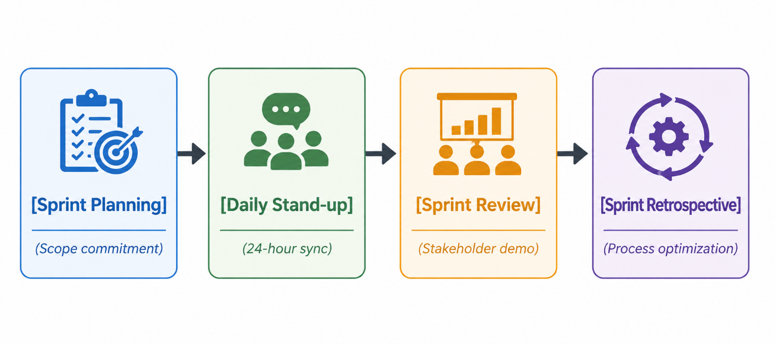
Daily Stand-up
A brief, 15-minute sync held every morning to keep the team aligned. To maintain momentum and speed, team members answer three standard questions:
- What did I accomplish yesterday?
- What will I focus on today?
- Are there any technical blockers in my way?
Sprint Review
A demonstration meeting held at the exact conclusion of a sprint. The data team showcases working dashboard components or analytical outcomes to business stakeholders. This meeting serves as an immediate feedback loop, ensuring that the assets being built align with what the business actually needs before moving into the next sprint.

16. Performance Framework
To evaluate an analyst's growth, productivity, and impact, organizations rely on layered performance frameworks. These systems align individual daily output with high-level corporate strategies.
KRA (Key Result Area)
Key Result Areas define the core operational boundaries and foundational responsibilities of a specific job profile. KRAs outline what an employee is paid to do on a recurring basis. For a Data Analyst Intern, the KRAs center on execution reliability and baseline operational health:
- Completing Assigned Work: Meeting sprint commitments and ensuring that ad-hoc queries, data extraction tasks, and baseline engineering tickets are delivered within the agreed-upon sprint timelines.
- Maintaining Quality: Ensuring that all code is fully commented, SQL queries are optimized for performance, and data outputs undergo rigorous peer review to avoid shipping broken charts or corrupt figures to stakeholders.
OKR (Objectives and Key Results)
OKRs are a forward-looking, goal-setting framework designed to drive ambitious growth and strategic alignment. While KRAs look at day-to-day duties, OKRs focus on big-picture impact and change.
Example Framework for an Analytics Team
- Objective: Improve the operational efficiency, response time, and trust index of the central business dashboard ecosystem.
- Key Results:
  - KR 1: Complete and deploy the restructured data model within 5 business days of sprint kick-off.
  - KR 2: Achieve 95% data accuracy across all automated tables, verified against production logs during QA testing.
KPI (Key Performance Indicator)
KPIs are quantifiable metrics used to track historical performance and measure how efficiently an individual or team hits specific operational targets.
Metric Category | KPI Name | Operational Target | Definition
Data Quality | Dashboard Accuracy | $$≥99.5\%$$ | The percentage of data points matching backend database sources without logic errors.
Velocity | Report Delivery Time | $$≤24\text{ Hours}$$ | The average time elapsed from an official data request to the final insight delivery.
Infrastructure | Data Quality Index | $$≤2\%$$ | The percentage of unresolved null fields or formatting anomalies remaining in production tables.
Efficiency | Task Completion Rate | $$≥90\%$$ | The percentage of committed user stories successfully moved to "Done" within a sprint cycle.
The Structural Synergy: KRAs define your responsibilities, OKRs chart your growth direction, and KPIs calculate your exact performance speed and quality. Combined, they form a holistic, numbers-backed roadmap for long-term career advancement.

Conclusion

Importance of Data Analytics
Data analytics has fundamentally transformed from a back-office corporate luxury into an absolute survival requirement for modern enterprises. In a hyper-competitive, digitized marketplace, organizations can no longer afford to operate on institutional intuition or unstructured guesswork. Data analytics provides the objective baseline that allows organizations to navigate market volatility, mitigate operational risks, optimize internal resource allocation, and deeply understand evolving consumer behaviors. By converting raw data footprints into strategic, forward-looking intelligence, analytics serves as the foundational engine driving modern business innovation and sustainable growth.

